**Practical 6**

**Character count program in string:**

|  |  |
| --- | --- |
|  | #include <stdio.h>  #include <string.h>  int main()  {  char s[1000], c;  int i, count = 0;  printf("Enter the string: ");  // Use fgets instead of gets  fgets(s, sizeof(s), stdin);  // Remove the newline character if present  if ((strlen(s) > 0) && (s[strlen(s) - 1] == '\n')) {  s[strlen(s) - 1] = '\0';  }  printf("Enter character to be searched: ");  // Using getchar to read the character to search  c = getchar();  // Count the occurrences of the character  for (i = 0; s[i]; i++)  {  if (s[i] == c)  {  count++;  }  }  printf("Character '%c' occurs %d times\n", c, count);  return 0;  } |

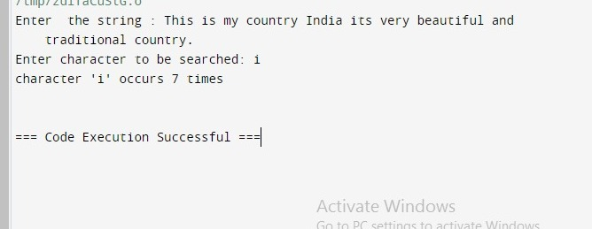

**Practical 7**

**Bits count program stuff :**

#include <stdio.h>

int countSetBits(int n) {

int count = 0;

while (n > 0) {

if (n % 2 == 1) {

count++;

}

n = n / 2;

}

return count;

}

int main() {

int num;

printf("Enter an integer: ");

scanf("%d", &num);

int result = countSetBits(num);

printf("Number of set bits in %d: %d\n", num, result);

return 0;

}

### Example Output:

Enter an integer: 29

Number of set bits in 29: 4